**XinBang 4060 Lasercutter Manual**

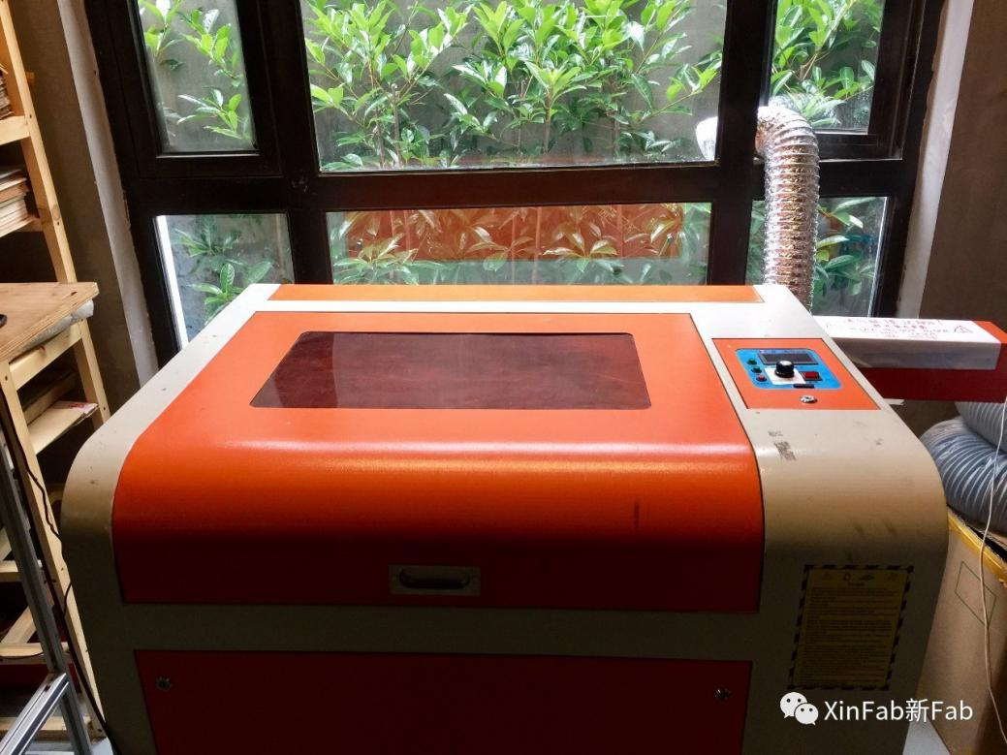

Specifications:

Working Area: 560mm x 360mm

Depth: 260mm

Power: 60W

Speed: 450mm/s max to engrave

50mm/s max to cut

(* lower the speed when it moves weird)

**Preparation for the file:**

1. If you need to cut and engrave in one job or engrave on a specific area, please create a rectangle for your design as a reference. It's helpful to get your work done on this machine.

e.g. here is the orginal file I want to cut and engrave in one job:



I create a rectangle as a reference for the machine can have a better understanding about what I want to do with it. Like this:



Later I'll explain it.

2. The thickness of the cutting line should be 0.1 pt.

If it's thicker than 0.1 pt in the cutting mode, the machine will recognise it as a shape that you want to cut the inner and outer outlines of this shape.

3. Separate your design into three parts: Engrave, Cut and Reference.

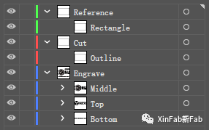

4. Export your file as ".pdf" file. This format can remember the layers that you just created.

**Calibration of the machine:**

1. Turn on the board near the machine and everything should be on.

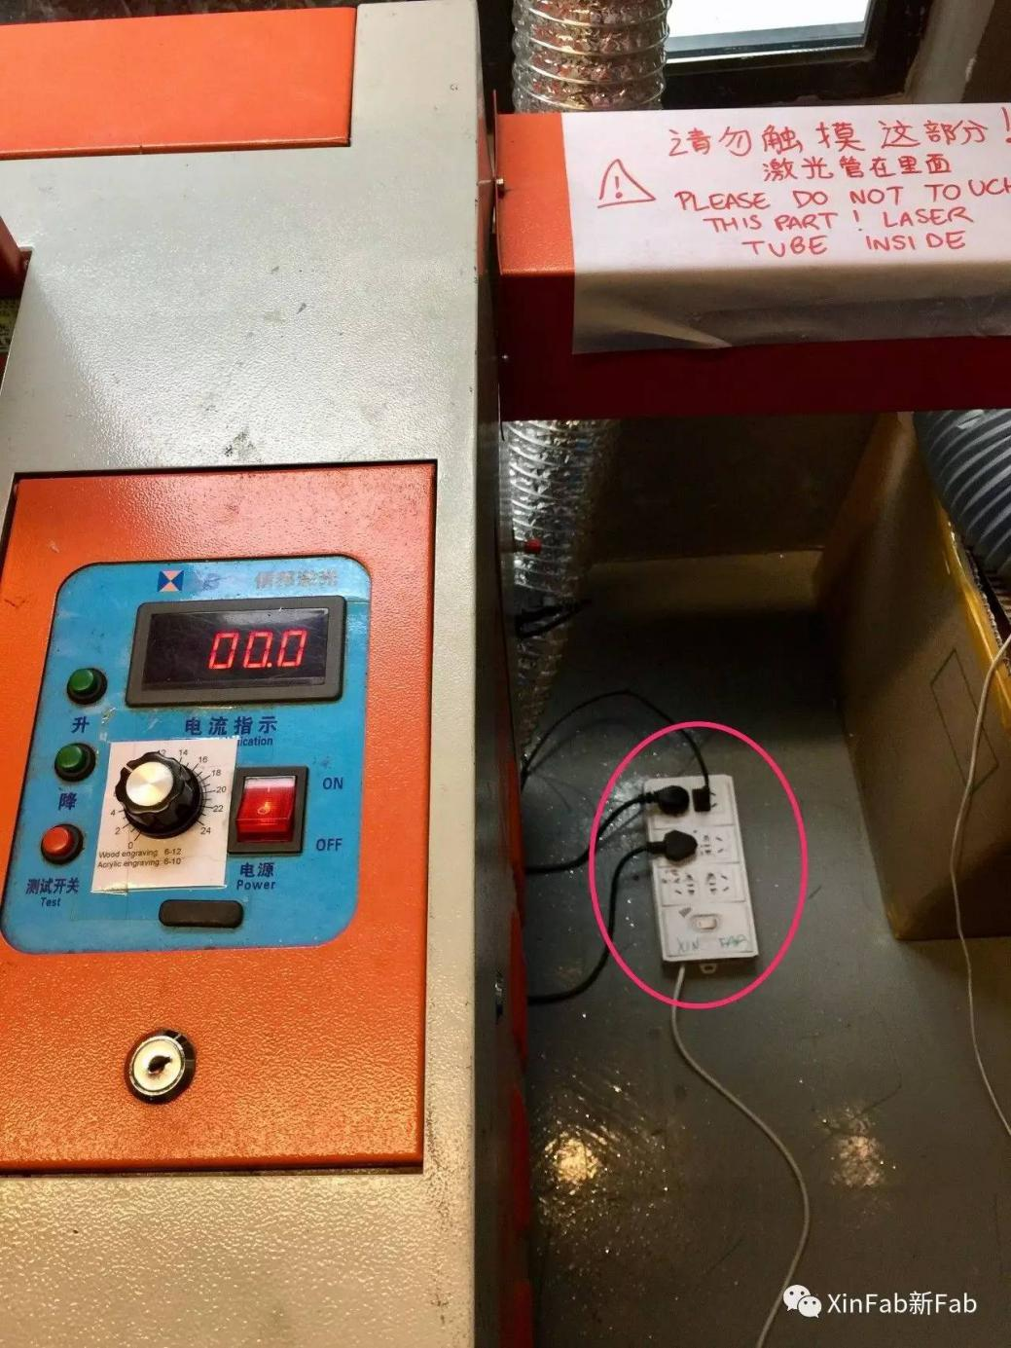

If the machine is off, you can turn on the switch.

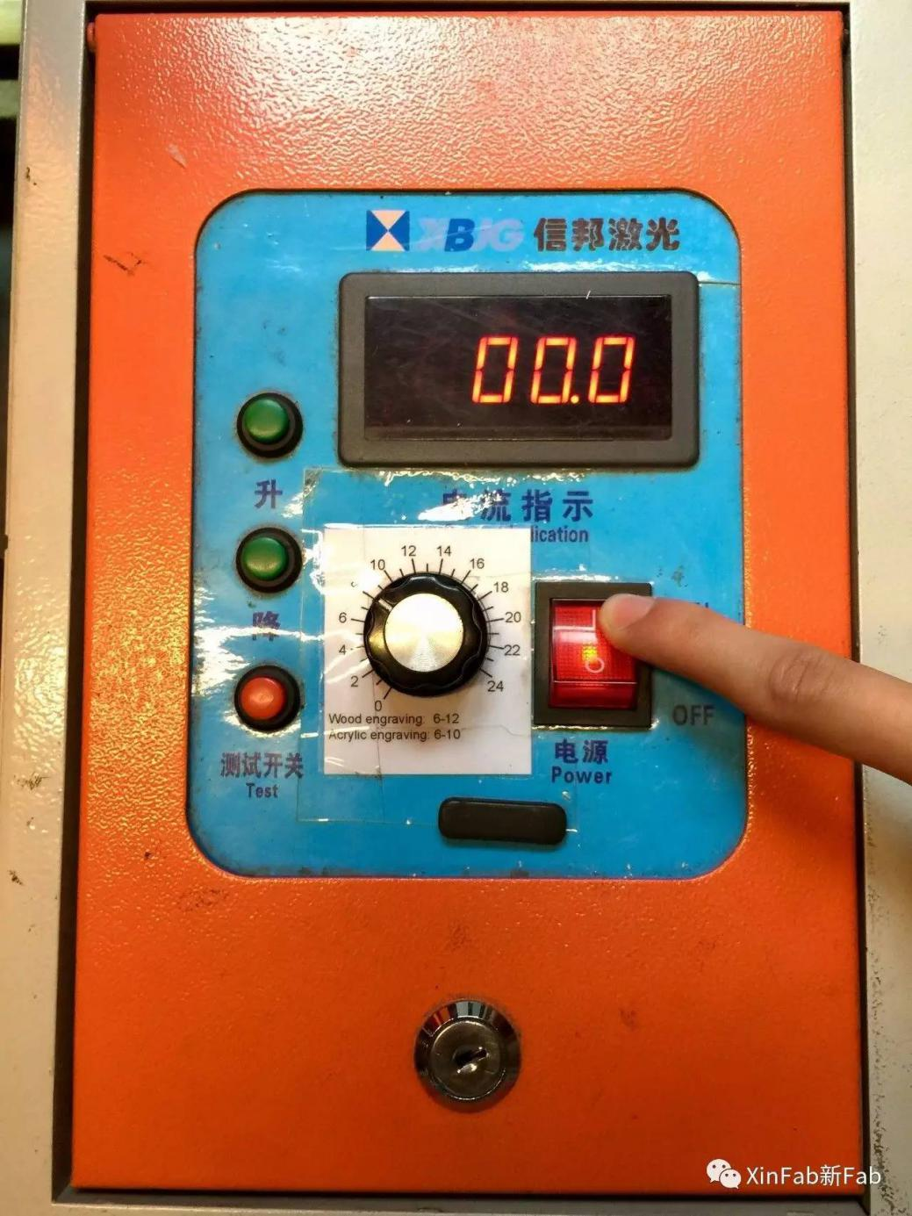

Check if the visible laser, air pump and water pump are working, and put the air pipe out of the window.

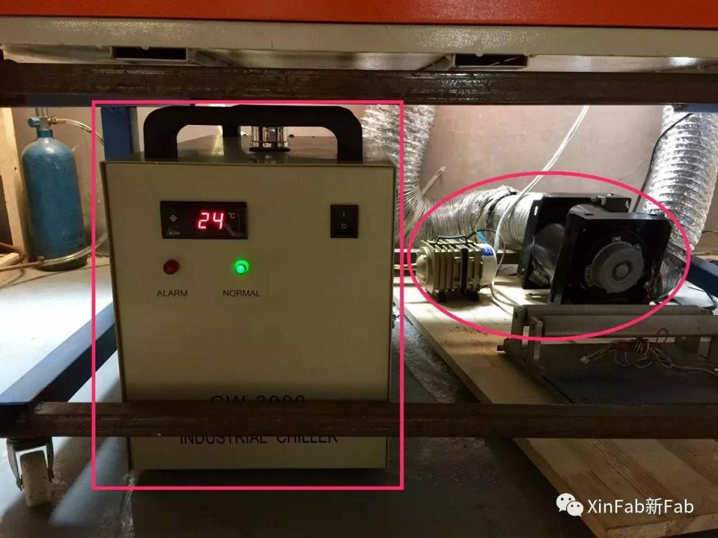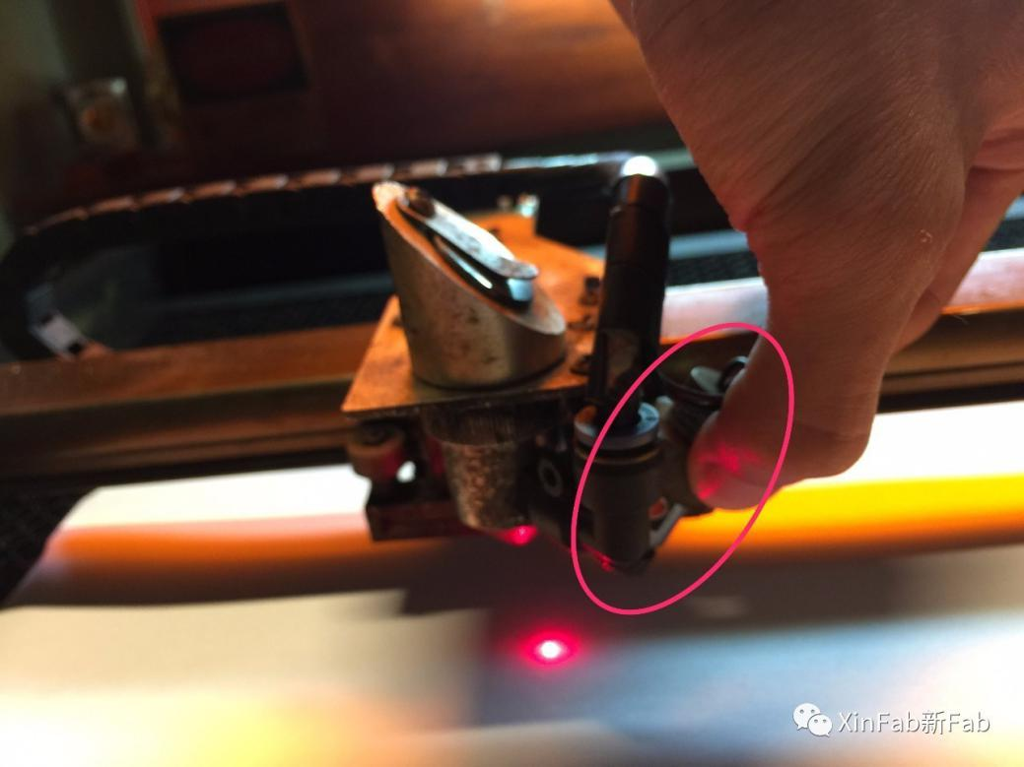

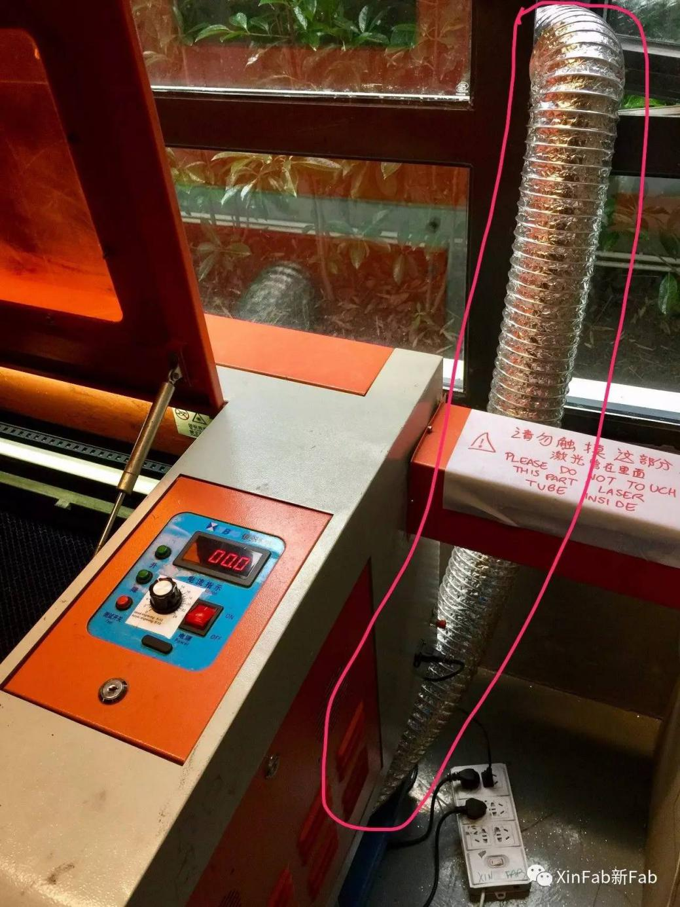

2. Put your material on the bed and carefully move the laser head above the material.

3. Press the button to calibrate the height of the bed, untill the caliborator just fits.

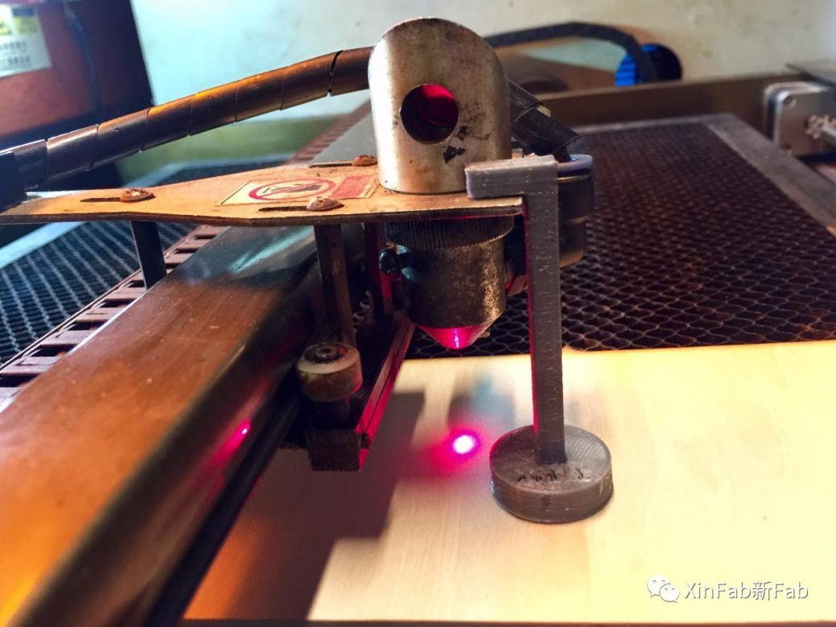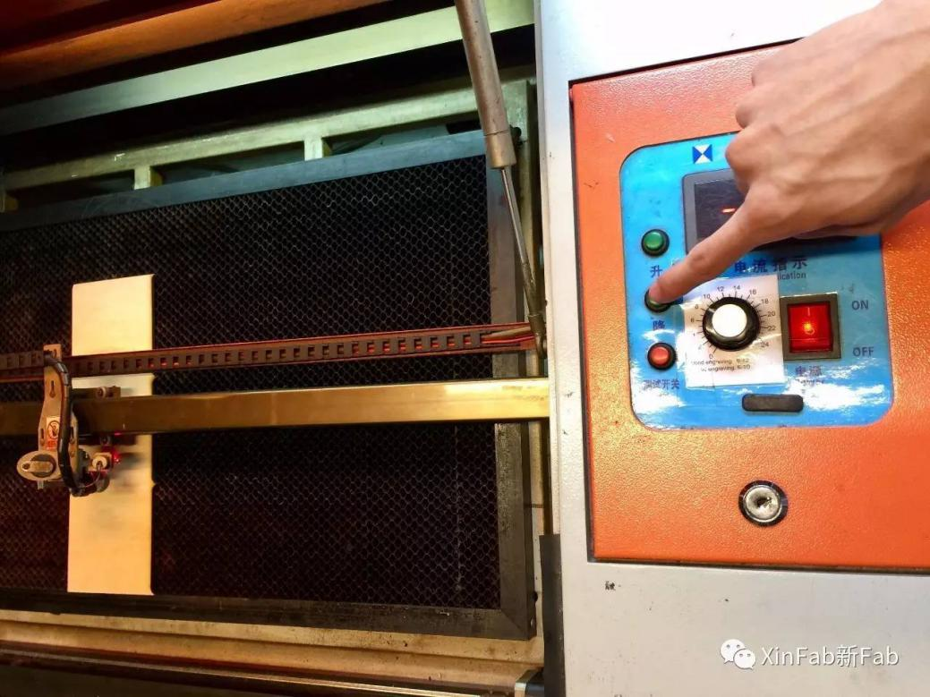

4. Choose the power of 6, press test button to burn a hole on the material. Adjust the visible laser(in the right) into the hole, that's where the power laser aims at.

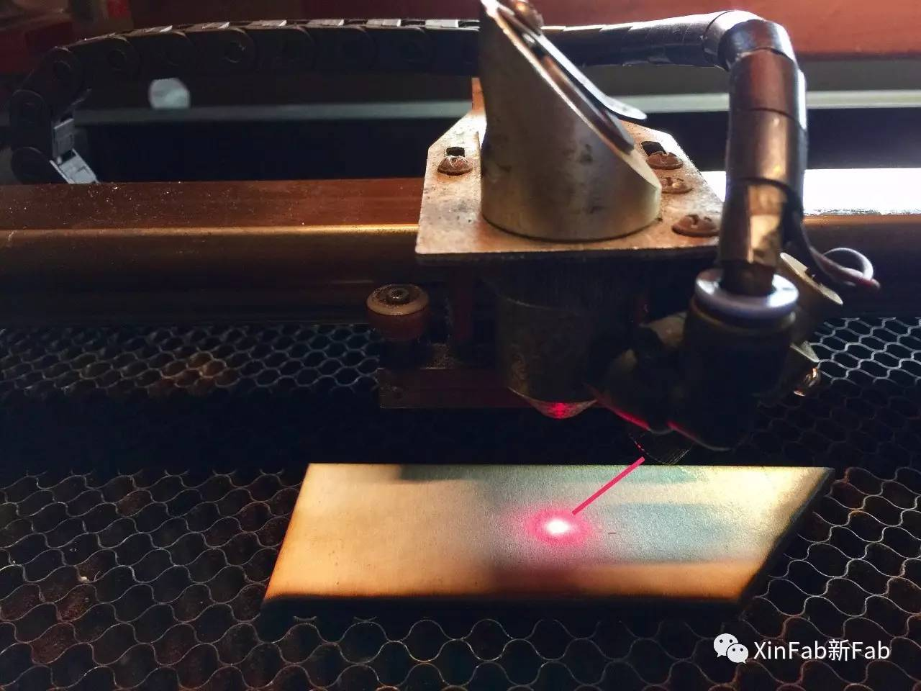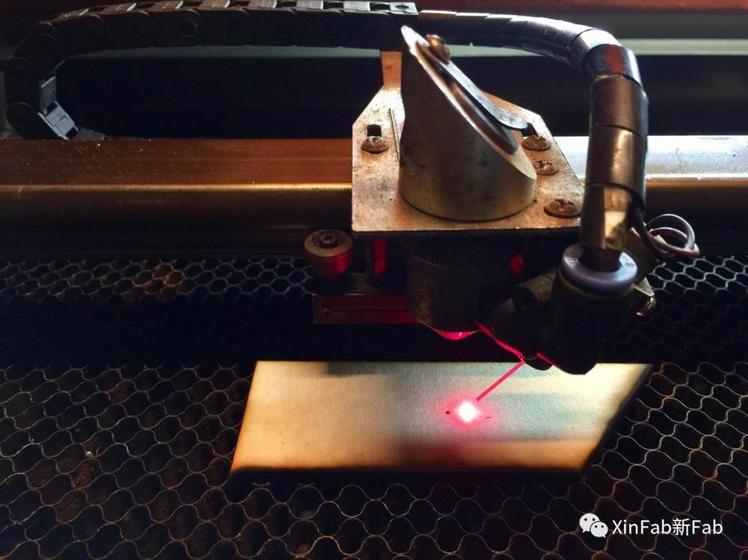

* When you use the machine the first time of the day or change different material, you have to go through this calibration.

**Add tasks to the machine:**

1. Open the CorelLASER on the desktop:

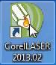

On the right top of it, you'll have the settings of the lasercutter system:

15

This is for engraving:

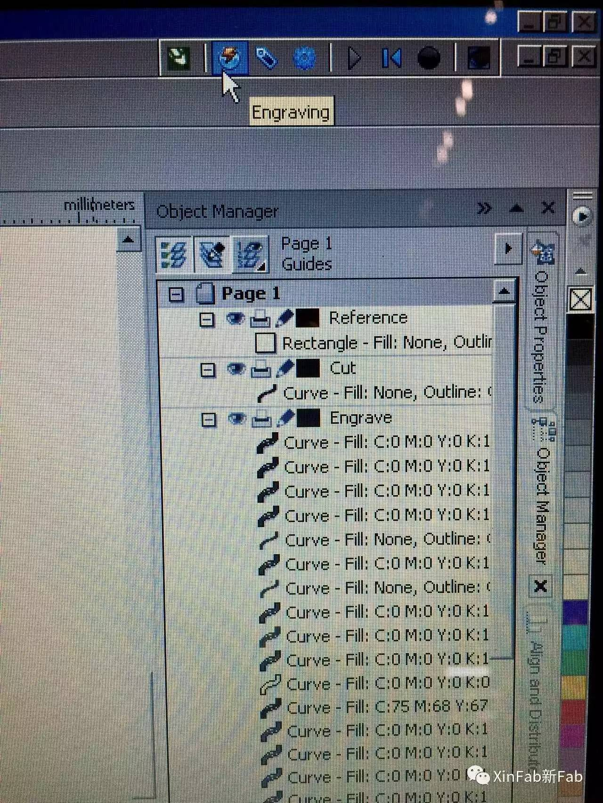

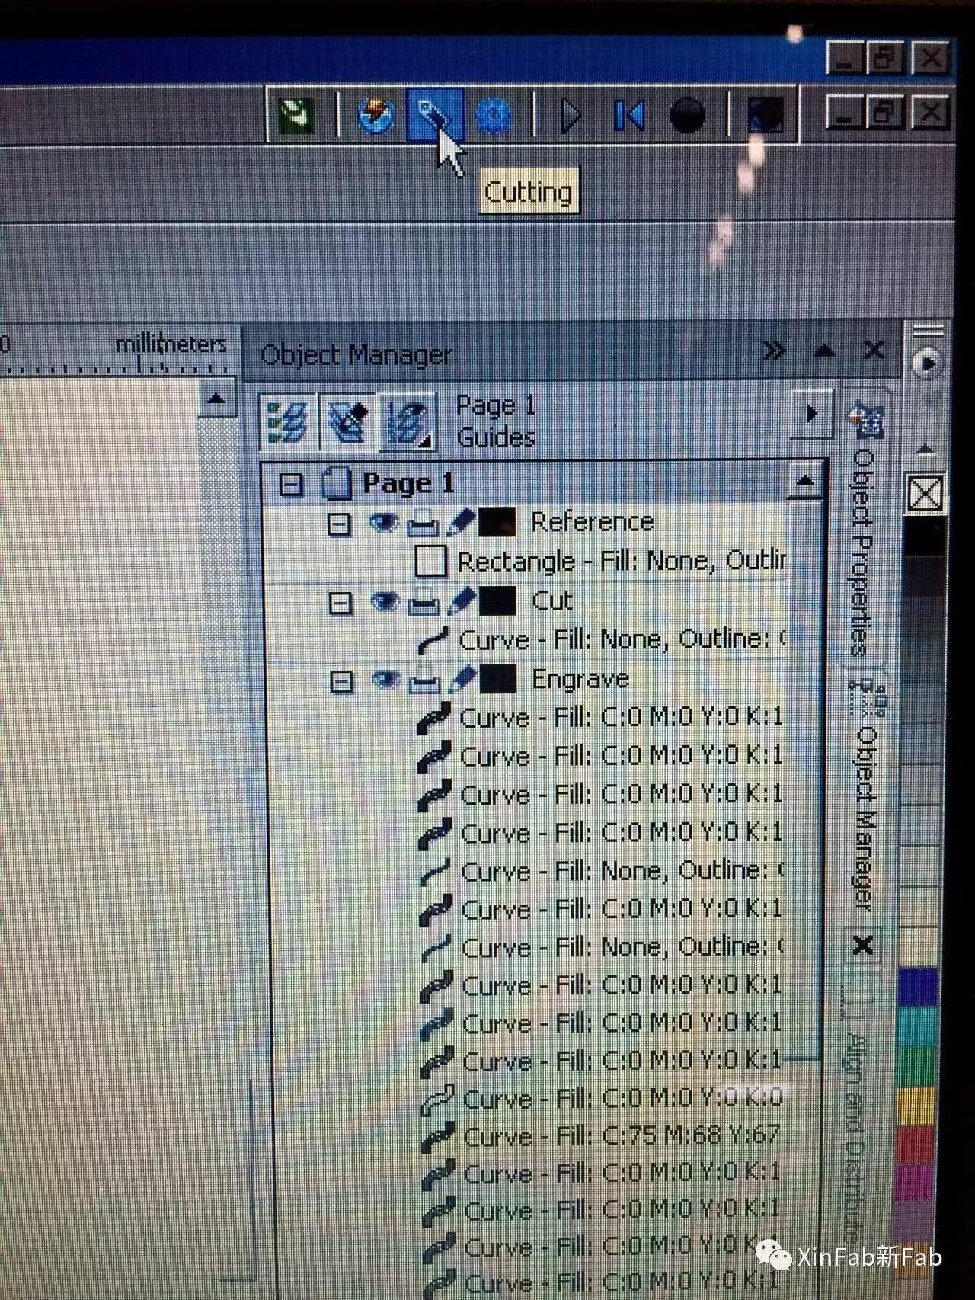This is for cutting:

2. Let's do the engraving first. In this step, keep the reference rectangle selecting.

Then, select the first parts you want to engrave.

Click on the engrave button, change the speed you need.

Click on the "Add task" button.

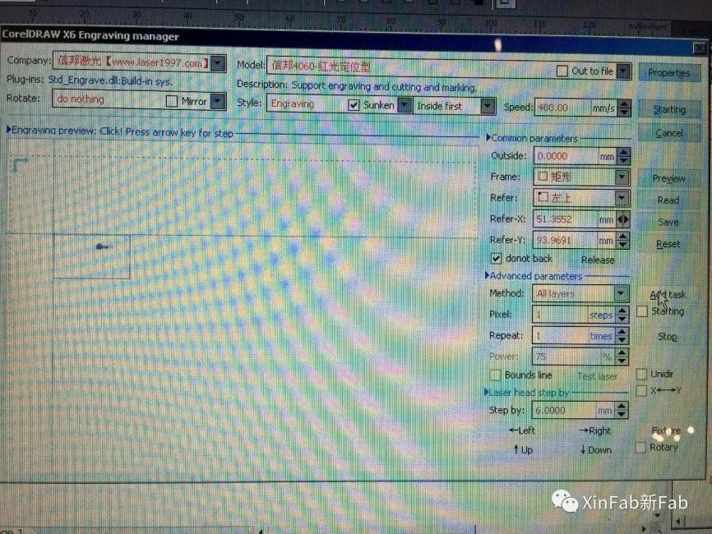

Unselect the first parts and select the second engraving parts with the reference rectangle selecting.

Click on the engrave button, change the speed you need.

Click on the "Add task" button.

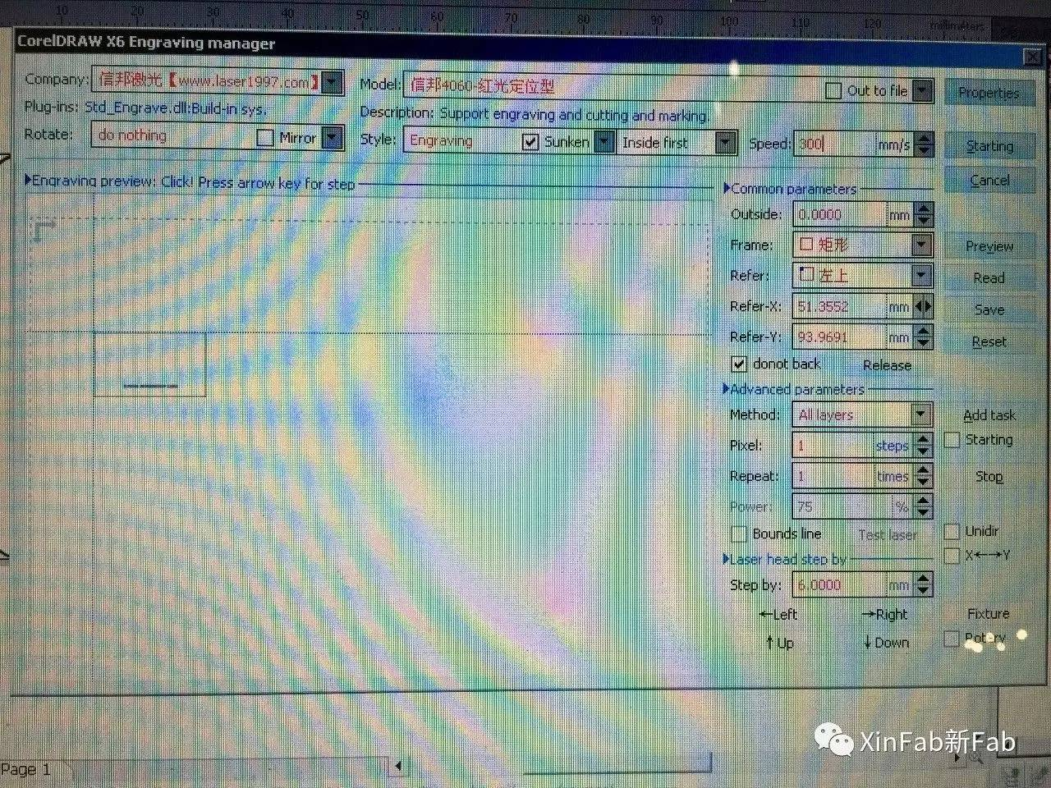

Repeat the process until all the engraving parts are added to the task.

3. Select the cutting part and click on the cutting button.

Check the "Bounds line".

Change the speed you need.

Check the "Starting" under the "Add task" button.

Click on the "Add task" button.

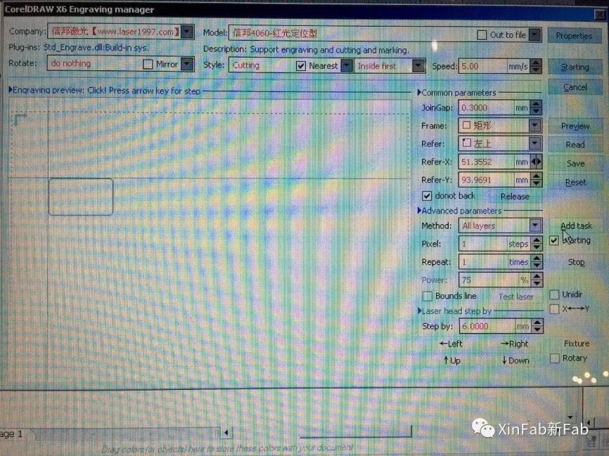

Now the machine will start to do the tasks following your order.

Material Settings:

Wood:

- Engraving

Power: 6-14

Speed: 450mm/s

- Cutting

Power: 14 for 4mm, 12 for 3mm, 10 for 2mm

Speed: 10mm/s